Design and optimization of patient-specific, pediatric laryngoscopes

###### R. Sims1, M. Boutelle1, J. Inziello1, and F. Lobo1*

1 PD3D Lab, University of Central Florida, Orlando, United States of America

* Corresponding author, email: [jstubbs@ist.ucf.edu](mailto:jstubbs@ist.ucf.edu)

Abstract: Place a brief summary of your work here. Do not use more than 100 words. 3D printing is of outstanding importance in medical engineering and has been growing continuously in recent years. From prostheses and soft implants to matrices for tissue engineering, additive manufacturing has decisive advantages for medicine. The scientific conference AMMM 2019 brings together engineers, scientists and technicians with physicians and entrepreneurs to discuss the latest achievements in 3D printing development for medicine.

# I. Introduction

* Laryngoscopes were first introduced in…
* The most modern laryngoscopes are…
* There are such things as disposable laryngoscopes…
* Laryngoscope blades vary per age group, but there is only # options for pediatrics…
* Difficulties with intubation represent the main cause of pediatric, anesthesia-related morbidities and mortality [1]. Even in scenarios where difficult intubations are expected, anesthesiologists know to have “all the equipment to hand,” which translates into a clutter of devices and cost inefficiencies [2].

The design of patient-specific devices requires several steps…

# II. Material and methods

## II.I. Patient Data

The raw patient data should be geometry of the tissue and bone in the patient, leaving the airway of the patient hollow. In most segmentation software, this is a simple task, and can even be done in Houdini, using our custom segmentation software, to avoid using different software.

## II.II. Process Overview

We used Houdini FX, a VFX software traditionally used in the film and games industries to create a process for rapidly segmenting airways from patient geometry, finding the average path through that airway, then using that data to procedurally design a laryngoscope that is sized to perfectly fit the patient it has been designed for. This process starts with importing patient data, which can be created using any software (including Houdini with our customized DICOM toolset built for Houdini). Next, the data can be segmented inside of Houdini to isolate the negative space of the patient’s airway. After that, a solver is ran to determine the path and width of the airway, before finally extruding the tool profile along the toolpath created from the patient data, and finally fabricating the new device using 3D printing technologies. This process can be described in several distinct parts: importing patient data, refining patient data, finding a close bounding shape, segmenting the airway from the rest of the patient data, finding the centerline, which can be exported for use in other cad software, or applied to the tool profile in Houdini to create a device.

## II.III. Segmentation

The segmentation step involves creating a shell around the base geometry, using a shrink-wrap operation, and then using a subtraction operation to cut the source patient geometry from the shell geometry. In order to shrink-wrap the patient, we first erode the volume of the surface of the patient, to remove any tubes or other elements that are stuck to the skin of the patient; this creates a cleaner surface to wrap. After this, we dilate the previously eroded surface to clear out any cavities that may be inside of the geometry, including the airway, ear canals and other empty spaces in the patient’s physiology. Then, projecting this surface onto the eroded surface, we create a volume that is then combined with the source patient geometry using a subtraction operation to pull out the negative space from the source geometry, which results in geometry consisting of the negative space in the patient, including the airway.

## II.IV. Pathfinding

After the airway volume has been segmented, there are two options for finding its center path, one being the use of a modified space colonization algorithm, and the other using Houdini’s native find shortest path node.

The space colonization method, takes an input point near the front of the volume, where the mouth would be, and using a point cloud defined inside of the airway’s volume to organically grow a path through the airway, which can be averaged to find a close approximation of the curvature of the airway.

The other option is to select a group of points at the mouth, and another group at the end of the airway, and to use find the shortest path between the two groups using a point cloud similar to the one used for space colonization method, and averaging the paths to find a centerline.

## II.V. Part Design

Using the airway path designed above, you can extrude and loft a tool shape along this path to create a laryngoscope that will follow the path of the airway, and can be quickly and easily customized to any patient.

## II.VI. Fabrication

Since this part was designed in a digital space, it can be easily exported for creation on a 3D printer. This methodology would allow for the rapid creation of one-time-use medical devices that could be designed on an as needed basis for patients as they enter a hospital with minimal wait time.

# III. Results and discussion

Table 1: Values used to achieve airway curvature

|  |  |  |  |
| --- | --- | --- | --- |
| **Parameter** | **Unit** | **Mean** | **SD** |
| Segmentation* | Density | 0.2 | 0.0 |
| Voxel Resolution1 | Millimeters | 0.56 | 0.33 |
| Erosion Amount | Millimeters | 2.4 | N/A |
| Dilation Amount | Millimeters | 8.0 | N/A |
| Point Separation2 | Millimeters | 2.33 | 0.94 |
| Frames3 | Number | 8.66 | 1.88 |

* Whenimporting the patient CT scan into Houdini, the software normalizes the values so that they can be displayed natively in the software. The value in this section represents the crossing point where the software determines what is considered solid, and what is not part of the surface.

1 Voxel resolution had to be decreased for some scans in order to maintain enough detail to portray the airway, as was the case for the patient in figure 1. This change is mainly cosmetic and does not affect other calculations.

2 Similarly to the above note, this number had to be changed in order to endure there were enough points scattered in parts of the volume that were otherwise too small.

3 depending on the length of the airway, more or less steps in the solving process may be required.

The results here show the values that we used across our segmentation and solving processes to achieve the effects shown in figures 1, 2, and 3. We had no variation in the amounts of erosion and dilation, which is the result of the patients all having similar age ranges, and feature dimensions. We expect that with a wider range of patient ages and sizes that those numbers will require more adjustment based on the dimensions of the features in those patients.

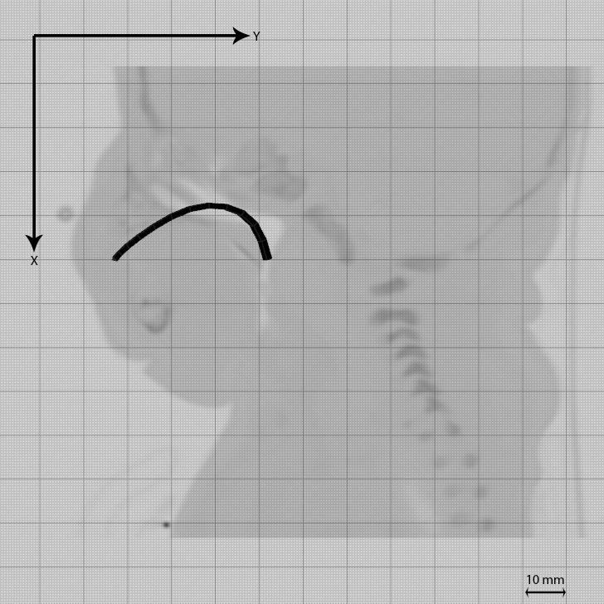

Figure 1

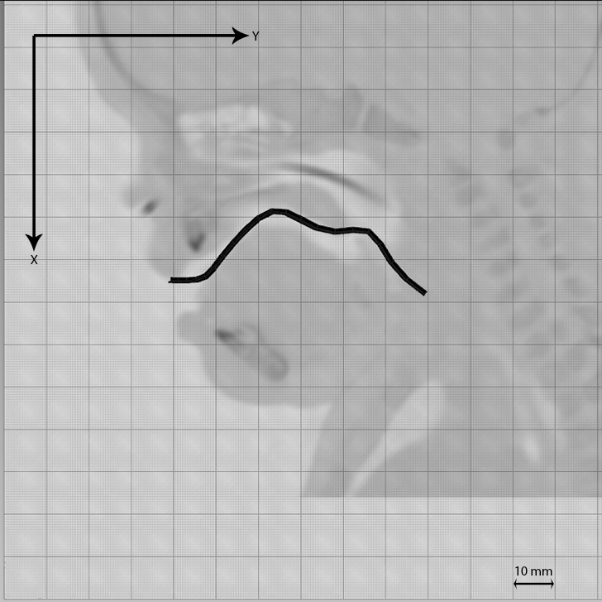

Figure 2

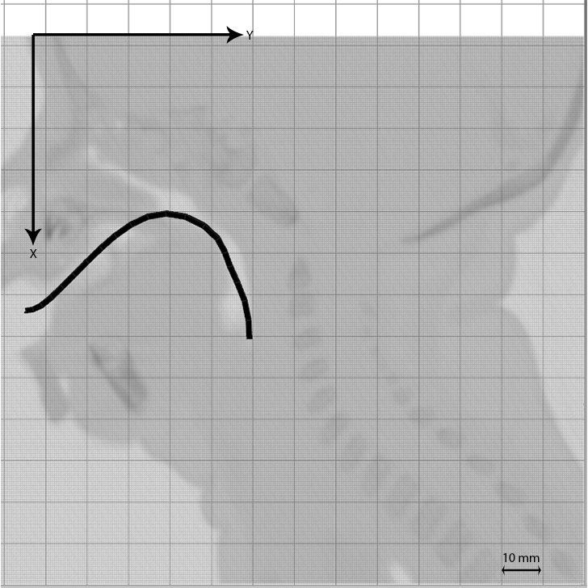

Figure 3

# IV. Conclusions

Although a conclusion may review the main points of the paper, do not replicate the abstract as the conclusion. A conclusion might elaborate on the importance of the work or suggest applications and extensions.

### Acknowledgments

##### The preferred spelling of the word “acknowledgment” in America is without an “e” after the “g”. Avoid the stilted expression, “One of us (R. B. G.) thanks . . .” Instead, try “R. B. G. thanks”.

### Author’s statement

##### Research funding: The author state no funding involved. Conflict of interest: Authors state no conflict of interest. Informed consent: Informed consent has been obtained from all individuals included in this study. Ethical approval: The research related to human use complies with all the relevant national regulations, institutional policies and was performed in accordance with the tenets of the Helsinki Declaration, and has been approved by the authors’ institutional review board or equivalent committee.

#### References

[1] M. Weiss and T. Engelhardt, "Proposal for the management of the unexpected difficult pediatric airway," *Pediatric Anesthesia,* no. 20, pp. 454-464, 2010.

[2] R. W. M. Walker and J. Ellwood, "The Management of difficult intubation in children," *Pediatric Anesthesia,* no. 19, pp. 77-87, 2009.

[3] A. Runions, B. Lane and P. Prusinkiewicz, "Modeling Trees with a Space Colonization Algorithm," *NPH,* 7, pp.63-70, 2007.